Housing Report

**2. Neighbourhood Plan Objectives given to Housing Group November 2016**

**HO1** *A mix of housing, both in size and tenure, will be delivered that caters for the full range of housing needs in the Parish*

***HO2 A****ffordable homes will be provided with an emphasis on those people with a local connection and need for accommodation.*

***HO3*** *New infill developments will be situated within and adjacent to existing settlements and* delivered on sites preferred by the local community. Development which risks merging two settlements will be resisted unless significant community benefit can be demonstrated.

**H04**. Development to the rear of property will be strongly resisted

***HO5*** *New buildings should be constructed on sites with minimal risk of flooding and capable sewer infrastructure*

***HO6.*** *New developments will have specifications with an emphasis on sustainability, including high quality design and build, good insulation and the capability to generate electricity*

**3a**. **Housing Needs Summary**

Bedfordshire Rural Communities Charity undertook a Housing Needs Survey for Northill Parish Council in July 2015 (BRCC 2015). The survey aimed to assess the need of local people for affordable and market housing within the Parish. Response rate was around 34% (331 responses were received from around 975 distributed). 61% of respondents thought affordable rented accommodation for local people was required, 53% were in favour of shared ownership and 54% thought purchase on the open market was appropriate. The report failed to make a distinction between Northill Parish and the village of Northill in its text which was confusing.

Affordable Housing Need

79% of the 331 overall respondents to BRCC 2015, in a multi choice question, thought one or more types of new affordable housing were needed. 1-2 bedroom houses were the highest category (58%) with bungalows (53%) following closely. The latter reflects the growth in ageing demographic within the parish NP 13.7% v CBC 8.7% (2011 census).

Assessment of survey results indicated that 14 units would be required to meet need until 2020 broken down into

2 x 1-2 bed bungalow (rent)

2 x 2 bed bungalow (shared ownership)

4 x 1-2 bed house (2 rent, 2 shared ownership)

4 x 2 bed house (3 rent, 1 shared ownership)

2 x 3 bed house (1 rent, 1 shared ownership)

**7 affordable properties are presently being built in Northill which leaves a requirement until 2020 for**

|  |  |
| --- | --- |
| **4 x 1-2 bed house** | **4** |
| **2 x 2 bed house** | **2** |
| **1 x 3 bed house** | **1** |

**Thereafter need should be reassessed through 2 further Housing Needs Assessments in 2020 and 2025. Substitution of houses built to Lifetime Homes criteria for bungalows would reduce costs while providing adaptable accommodation.**

Shared ownership has proved difficult for local people to buy into and obtain mortgages for, leading to one such property taking 1 year to fill. **Presently shared ownership properties are obligatory within affordable housing sites under CBC ruling. It may be more productive to have a local ruling that where affordable housing is offered initially as shared ownership and not filled within an agreed time, it can be let instead.**

Affordable Housing Provision

Central Bedfordshire’s Affordable Housing and Neighbourhood Plans Briefing Note, July 2014. (CBC 2014a) has been released to the Northill Parish Neignbourhood Plan Steering Group by Central Bedfordshire as their most up to date position in this area:

Affordable Housing is usually provided by a Registered provider and can be affordable rented property (where rent is charged at up to 80% of market value), or it can be shared ownership in which people can own a share in the property and pay rent on the remainder. At present, households seeking affordable rented accommodation through any new exception site development would have to apply through the Bedfordshire Choice Based Lettings scheme, through which they would have to demonstrate both a housing need and a local connection to Northill Parish. **The only way to be sure affordable housing meets the needs of people with a local connection first is through a rural exception site which can be developed adjacent or outside the settlement envelope (CBC 2014a).**

Market Housing Need

BRCC( 2015) in their survey analysis stated that market housing policies for the Neighbourhood Plan (e.g. proposed numbers, size and type) would need to have a broad evidence base. This would include local housing need identified through BRCC (2015) and consideration of the wider housing market, as there would be no restrictions placed on the sale of this housing.

Analysis of the survey responses concluded a need for 2 and 3 bed bungalows or retirement properties to meet the needs of existing owner occupier residents wishing to downsize and remain in the parish, freeing up larger properties for growing families. The survey notes that there is no guarantee that housing sold on the open market will be bought by people with a local connection to Northill***.* Provision of up to 10 market housing units was thought to meet a reasonable proportion of the need while being in keeping with the size of the parish. According to the 48 respondents eligible to answer the question on market housing in the BRCC survey, a housing mix of 2 bed properties x 5, 3 beds+ x 3. 3 beds properties x 2 was favoured.**

Market Housing Provision

Current Central Bedfordshire policy (CBC 2014a) requires the provision of affordable housing on all schemes of 4 or more units, 35% of the total number of units to be provided as affordable housing. This policy is likely to change once the emerging Development Strategy has been adopted. The Strategic Housing Market Assessment update 2014 (SHMA) requires a tenure split of 63% affordable rent and 37% intermediate tenures (shared ownership). For example this would mean 4 affordable houses for a market housing scheme of 12 properties (either 3 affordable lets/1 shared ownership or 2 or each) (CBC,2014a).

Under the current CBC lettings policy, those in the greatest housing need are allocated housing regardless of local connection. The proposed new Housing Allocations Policy does incorporate a local connection criteria for access to the Housing Register. The proposal is 3 years continuous residing in the area prior to application***.*** Although the local connection criteria has been incorporated within the new Housing Allocation Policy, the properties will be allocated on need basis (CBC 2014a). **Affordable housing within a market housing site would be open to the whole housing list and not guaranteed to meet the needs of local people**

Rural Exception sites

CBC (2014a) states that rural exception sites are a valuable source of new properties to help meet the growing demand for affordable housing and to promote rural sustainability. The Council gives such properties special treatment under its planning policy and its Housing Allocation Policy. Affordable housing delivered through rural exception sites will remain affordable in perpetuity. **Historically exceptions sites have been required to deliver 100% affordable housing. However, the emerging Development Strategy will allow for no more than 20% of the total number of units to be delivered as market housing to enable the development to be viable.** A housing needs survey will need to be undertaken to assess the level of housing need in the parish (CBC,2014a**).** Following CBC (2014a) guidance, if 8 affordable units were built within Northill Parish to meet the identified need for 7 and on a rural exception site, 2 market houses would be allowable under the emerging strategy and the affordable housing would be for local people first and could presumably be built outside the settlement area. **CBC (2014a) suggestion could be incorporated into a Neighbourhood Plan policy on rural exception sites.**

CBC (2014a) states Rural Exception sites have a separate Local Lettings Policy. The intention is that the properties on such sites will be let to applicants having a local connection with the Parish in which the site is situated. Where there are no eligible applicants with such a local connection, allocation can be made to eligible applicants with a local connection to a neighbouring Parish; and if there is still no such applicants, an allocation can be made to an applicant with a local connection to the Central Bedfordshire Council area (CBC 2014a). **The Neighbourhood Plan could use a separate rural exception site local lettings policy compliant with CBC Local Letting’s Policy, but differentiated with local need.**

**3b. Housing Mix**

Policy 30 of CBC 2014 emerging plan requires a mix of housing types, tenure and size to encourage sustainable mixed communities. Appropriate mix should be decided using:

* the most up-to-date, strategic evidence base on the housing needs across Central Bedfordshire and adjoining housing markets.
* local Housing Needs Assessments
* local Authority Population & Household projections
* census information
* current Housing Market Conditions
* locality and characteristics of the site including it’s accessibility to local services
* existing housing mix of the locality

This stance is further emphasised in CBC (2014a) which states the in rural areas, exercising the duty to cooperate with neighbouring authorities, local planning authorities should be responsive to local circumstances and plan housing development to reflect local needs, particularly for affordable housing, including through rural exception sites where appropriate. Local planning authorities should in particular consider whether allowing some market housing would facilitate the provision of significant additional affordable housing to meet local needs.

The Neighbourhood Plan wishes to incorporate housing mix to deliver affordable housing as it agrees with the underlying principles of policy 30 and can see that developments of mixed housing could be made more attractive financially to developers than rural exception sites. However Northill Parish has exhausted land within the settlement boundaries of the villages. Therefore rural exception sites are the only viable option for achieving affordable housing for local people. The preferred option is to build the equivalent of a rural exception site using mixed housing and retaining the local benefit. **The Neighbourhood Plan should have a policy on rural exception sites using CBC rural exception site Local Lettings Policy. Rural exception sites should allow a proportion of market housing to make the site viable and sustainable but still retain the affordable housing for local connected people first.**

**3c. Truly affordable property**

The distinction was made, in the workshops held with parishioners, between affordable housing using CBC definition and truly affordable homes. Truly affordable homes are what parishioners want. NPPF (2012) para 50. challenge to local authorities to create high quality homes, widen opportunities for home ownership and create sustainable, inclusive and mixed communities presents problems when the need locally is for affordable rent and buy properties which can only be specified for local people on an exception site. **Starter homes, self build and modular build have been examined in a bid to explore the potential for truly affordable homes. (See appendix 3)**

**3d Central Bedfordshire’s Design Guide** (**CBC 2014b)**

To promote sustainable development in rural areas, housing should be located where it will enhance or maintain the vitality of rural communities. For example, where there are groups of smaller settlements, development in one village may support services in a village nearby. Local planning authorities should avoid new isolated homes in the countryside unless there are special circumstances such as:

* the essential need for a rural worker to live permanently at or near their place of work in the countryside; or
* where such development would represent the optimal viable use of a heritage asset or would be appropriate enabling development to secure the future of heritage assets; or
* where the development would re-use redundant or disused buildings and lead to an enhancement to the immediate setting; or
* the exceptional quality or innovative nature of the design of the dwelling.

**Development within hamlets needs to conform to Central Bedfordshire’s design guide. A design that delivers truly affordable modular or eco housing might be considered appropriate under the category of “exceptional quality or innovative nature of the dwelling design.” However it would have to meet the following criteria from CBDG**

* **be truly outstanding or innovative, helping to raise standards of design more generally in rural areas;**
* **reflect the highest standards in architecture;**
* **significantly enhance its immediate setting; and**
* **be sensitive to the defining characteristics of the local area.**

CBDG also states that local and neighbourhood plans should develop robust and comprehensive policies that set out the quality of development that will be expected for the area. Such policies should be based on stated objectives for the future of the area and an understanding and evaluation of its defining characteristics.

**The neighbourhood plan should have a policy on quality of development based on stated future objectives for the area and both understanding and evaluation of its defining characteristics**

**4. Introduction**

**4a National perspective**

National policy with regard to housing is driven by the National Policy Framework 2012 which sets out the Government’s planning policies for England and how these are expected to be applied. National policy statements form part of the overall framework of national planning policy, and are a material consideration in decisions on planning applications. The framework allows Central Bedfordshire Unitary Authority and the parishioners of Northill Parish to produce their own distinctive local and neighbourhood plans, which reflect the needs and priorities of their communities. Central Bedfordshire as the authority preparing plans for and taking decisions on traveller’s sites should have regard to both the Framework and the Governments planning policy for traveller sites (NPPF 2012)

“The purpose of the planning system is to contribute to the achievement of sustainable development which has mutually dependent economic, social and environmental dimensions:

* **an economic role** – contributing to building a strong, responsive and competitive economy, by ensuring that sufficient land of the right type is available in the right places and at the right time to support growth and innovation; and by identifying and coordinating development requirements, including the provision of infrastructure;
* **a social role** – supporting strong, vibrant and healthy communities, by providing the supply of housing required to meet the needs of present and future generations; and by creating a high quality built environment, with accessible local services that reflect the community’s needs and support its health, social and cultural well-being; and
* **an environmental role** – contributing to protecting and enhancing our natural, built and historic environment; and, as part of this, helping to improve biodiversity, use natural resources prudently, minimise waste and pollution, and mitigate and adapt to climate change including moving to a low carbon economy.” (NPPF 2012)

**4b Local perspective**

At present Central Bedfordshire Council has no local plan therefore neighbourhood plans must take into account the last published Local Plan, CBC (2009) Local Development Framework Former Mid Bedfordshire Area Core Strategy and Development Management Policies, which is now out of date. Central Bedfordshire (2014) is the only published emerging plan and has yet to be ratified. In addition CBC has no specific deliverable sites within a five years housing plan. Relevant policies within Central Bedfordshire Council for the supply of housing are not considered up-to-date if CBC cannot demonstrate a five-year supply of deliverable housing sites.

To deliver a wide choice of high quality homes, widen opportunities for home ownership and create sustainable, inclusive and mixed communities, local planning authorities should:

* plan for a mix of housing based on current and future demographic trends, market trends and the needs of different groups in the community (such as, but not limited to, families with children, older people, people with disabilities, service families and people wishing to build their own homes);
* identify the size, type, tenure and range of housing that is required in
* particular locations, reflecting local demand; and
* where they have identified that affordable housing is needed, set policies for meeting this need on site, unless off-site provision or a financial contribution of broadly equivalent value can be robustly justified (for example to improve or make more effective use of the existing housing stock) and the agreed approach contributes to the objective of creating mixed and balanced communities. Such policies should be sufficiently flexible to take account of changing market conditions over time.

**4c Northill Parish**

Neighbourhood plans should support both the National Policy Framework and the Local Plan’s strategic development needs, while shaping and directing any required local development which falls outside the strategic elements of the Local Plan.

Parishes and neighbourhood forums can use neighbourhood planning to:

* set planning policies through neighbourhood plans to determine decisions on planning applications; and
* grant planning permission through Neighbourhood Development Orders
* and have Community Right to Build Orders for specific development which complies with the order

The presumption in favour of sustainable development running through both plan-making and decision-taking means that neighbourhoods should:

* develop plans that support the strategic development needs set out in Local Plans, including policies for housing and economic development;
* plan positively to support local development, shaping and directing development in their area that is outside the strategic elements of the Local Plan; and
* identify opportunities to use Neighbourhood Development Orders to enable developments that are consistent with their neighbourhood plan to proceed.

NPPF (2012)sets out core land-use planning principles which should underpin both neighbourhood plan-making and decision-taking. These 12 principles are that planning should:

1. be genuinely plan-led, empowering local people to shape their surroundings, with succinct local and neighbourhood plans setting out a positive vision for the future of the area. Plans should be kept up to date and be based on joint working and co-operation to address larger than local issues. They should provide a practical framework within which decisions on planning applications can be made with a high degree of predictability and efficiency;
2. not simply be about scrutiny, but instead be a creative exercise in finding ways to enhance and improve the places in which people live their lives;
3. proactively drive and support sustainable economic development to deliver the homes, business and industrial units, infrastructure and thriving local places that the country needs. Every effort should be made objectively to identify and then meet the housing, business and other development needs of an area, and respond positively to wider opportunities for growth. Plans should take account of market signals, such as land prices and housing affordability, and set out a clear strategy for allocating sufficient land which is suitable for development in their area, taking account of the needs of the residential and business communities;
4. always seek to secure high quality design and a good standard of amenity for all existing and future occupants of land and buildings;
5. take account of the different roles and character of different areas --protecting the Green Belts around them, recognising the intrinsic character and beauty of the countryside and supporting thriving rural communities within it;
6. support the transition to a low carbon future in a changing climate, taking full account of flood risk and coastal change, and encourage the reuse of existing resources, including conversion of existing buildings, and encourage the use of renewable resources (for example, by the development of renewable energy);
7. contribute to conserving and enhancing the natural environment and reducing pollution. *Allocations of land for development should prefer land of lesser environmental value, where consistent with other policies in this Framework*;
8. encourage the effective use of land by reusing land that has been previously developed (brownfield land), provided that it is not of high environmental value;
9. promote mixed use developments, and encourage multiple benefits from the use of land in ------- rural areas, recognising that some open land can perform many functions (such as for wildlife, recreation, flood risk mitigation, carbon storage, or food production);
10. conserve heritage assets in a manner appropriate to their significance, so that they can be enjoyed for their contribution to the quality of life of this and future generations;
11. actively manage patterns of growth to make the fullest possible use of public transport, walking and cycling, and focus significant development in locations which are or can be made sustainable; and
12. take account of and support local strategies to improve health, social and cultural wellbeing for all, and deliver sufficient community and cultural facilities and services to meet local needs.” (NPPF 2012)

CBC (2014) emerging plan states that a grading system for the quality of agricultural land has been in place for many years. Any development proposal, identified to be within the most valuable agricultural land (grades 1-3a), must consider alternatives in areas of less valuable agricultural land. If there are no viable alternatives, development within higher grades of valuable agricultural land may be considered. These criteria should be adopted by the Neighbourhood Plan Steering Group in deciding where development is best situated (CBC 2014). However there is no definitive explanation that could be found of the difference between the grading in parts of 3 and all land within the parish is within 1-3

**Northill Parish Neighbourhood Plan should consider inclusion of the following aspects within their assessment of preferred sites:**

* **Definitions of**
  + **high quality design**
  + **Conversion of existing buildings**
* **Prioritising re-use of brownfield sites**
* **Suggesting the use of orchard or allotment as part of a development**
* **Using access to food shops/schools/bus stops as criteria for inclusion/exclusion re preferred sites**
* **Using the remainder of site assessment questions to shortlist land for development in addition to parishioners preferences.**

**5. Relevant Organisations/Interested Parties**

* Department for Communities & Local Government
* Central Bedfordshire Unitary Authority
* Any other Local Authority which might be affected by Central Bedfordshire’s emerging Local Plan.
* Any other neighbourhood/parish which might be affected by the Northill Parish Neighbourhood Plan
* Anglia Water
* Landowners
* Developers
* Parishioners

**6.Evidence**

1. **Workshops**

Workshops were conducted in Spring 2015 according to the Northill Parish Neighbourhood Plan consultation statement. The results are shown on the table below. Findings were used to compile a questionnaire which was sent to every household in the parish.

**Neighbourhood Plan Workshop Findings with Reference to Housing**

| **Criteria** | **No. table -comments** | **Summary of aspirations** |
| --- | --- | --- |
| Potential housing site | 43 | Number of sites deemed suitable by parishioners for possible development |
| Range of housing type required | 18 | Mixed and affordable housing required to buy or rent with affordable housing being most important. For young people, older people and families with local connections and from outside the parish. Smaller family homes – 1/2 bed, 2/3 bed. 4 bed houses wanted by some but 4,5 and 6 bed houses not wanted by others. Retirement complex mentioned |
| Affordable housing | 17 | Need for housing association affordable housing and affordable housing to buy. 5-10% deposit – 10-15K maximum. Price therefore 100K to 150K. |
| Quality of build | 16 | Well insulated buildings, eco friendly, good landscaping, low energy, parking required for cars, adequate size bedrooms, beyond standard of minimum building regulations, sustainable and long lasting, design relevant and sympathetic, not above two stories, good thermal efficiency, correctly proportioned (dining room bigger than toilet), use materials that will not deteriorate over time, garden, cheap to run, easy to maintain, incorporating the principles of carbon-neutral building e.g. “Passivhaus” standards, designed for lifelong living, incorporating allotments/orchard in development |
| Improve infrastructure facilities | 12 | Opposition to further development – can the existing infrastructure cope |
| Preserve rural parish | 11 | Style and aesthetic concern about effect additional business development would have on small parish. Environmental/greenspace considerations |
| Small developments | 10 | Small developments of less than 12 dwellings using infill between houses but not development behind existing gardens or on agricultural land. Less chance of issues with integration if small. Build to the side rather than the back of properties. Build along roadside ie frontage development. Less impact on environment and residents. Do not eat into land behind houses |
| Small / infill development | 10 |
| Is the site to the rear of existing property | 7 |
| Social housing | 6 | Word social used interchangeably with affordable housing. Potential for misunderstanding. Different meanings need to be explained in text. |
| Planning in keeping with village | 6 | Should not develop on every field gap available. Averse to Greenfield development |
| No ribbon development between villages | 5 | Not building or extending between settlements as the unique character of parish will suffer. |
| Housing needs survey | 4 | Established housing need rather than want should take priority |
| Sheltered accommodation required | 3 | Might release larger properties for sale on open market and house older people renting from housing association in smaller properties |
| Traveller sites | 3 | No further sites required |
| Housing limit | 1 | No further development |

**b) Questionnaire**

Questionnaire return

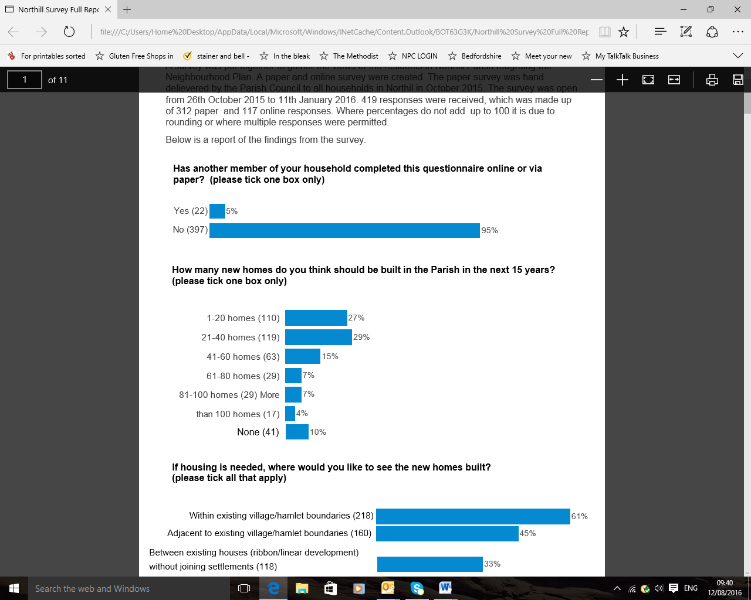**Figure 1**

**Figure 1**

There were ten questions in the Parish wide Questionnaire referring to housing and these are illustrated in the figures below. Figure 1 shows that 419 parishioners (18.4%) completed the questionnaire for neighbourhood planning. This is considered an acceptable return.

Amount of housing

**Figure 2**



Figure 2 shows that 408 parishioners (17.9% of the parish population) gave their views about the number of houses to be built in the parish in the next 15 years. 270 (66%) of those completing this question wanted to see 40 or less homes built (including 10% who wanted no new homes).

CBC LDF 2009 requires 10% of its total development to be accomodated in large (such as Upper Caldecote) and small (such as Ickwell and Northill) villages throughout the unitary authority. The scale of any type of new development should reflect the scale of the settlement in which it is located. The emphasis for development is contained in the following criteria

* has the clear potential to support and retain existing local services;
* will bring forward important new services or community infrastructure;
* is targeted at bringing forward new affordable or specialist housing at rural settlements where there is a specific local housing need; or
* would lead to the beneficial reuse of previously developed land.
* Is conveniently located to access local services and faciltiies

CBC 2014 emerging LDF has a presumption in favour of sustainable development. The Council states it will protect the open countryside, safeguard landscapes against inappropriate development and work to ensure new development works with the landscape. In addition to strategic sites which do not include Northill Parish, development will also be brought forward through Neighbourhood Plans, the Market-Led Sustainable Development Policy and the proposed Allocations Local Plan.

Both the existing CBC 2009 local plan and the emerging plan CBC 2014 adopt a settlement hierarchy approach to development in which small scale allocations of new homes, jobs and community facilities that reflect the size and character of the community will be allowed in large and small villages such as Upper Caldecote, Ickwell and Northill. CBC 2014 emerging plan (exception to settlement envelope policy) defines small scale housing development as 30 dwellings for Upper Caldecote and 15 each for Northill and Ickwell for the duration of the plan, unless local support indicates otherwise.

**The desire amongst parishioners for 40 or less dwellings in the next 14 years reflects Central Bedfordshire’s stance in both CBC (2009) and CBC (2014). Northill Parish is not considered to be a key centre for development and change in either document. At the time of writing this report ( March 2017) , CBC had not achieved its Five Year Land Supply targets. Provision could be made to accommodate a small number of properties should this be required.**

Location of development

**Figure 3**



Figure 3 indicates a strong preference for development within the settlement boundaries (218/61%) or adjacent to the settlement boundaries (160/45%) rather than within the surrounding countryside. This would automatically rule out development within the hamlets as they have no settlement boundary. Settlement boundaries are reserved for large (Upper Caldecote) and small (Northill & Ickwell) villages in the context of Northill Parish. There is also a desire for building between existing houses in a ribbon/linear way but not to the extent that this joins up the various villages/hamlets (coalescence).

Preventing Coalescence

The Parish consists of various sized settlements, each with its own unique atmosphere, part of which is derived from the separation afforded by the intervening countryside. A typical comment was “not building or extending between settlements as the unique character of the parish will suffer”. Maintaining individual identity of the constituent parts of the parish (preventing coalescence) was thought to be important

Infill

CBC (2009) defines infill development as small-scale development utilising a vacant plot which should continue to complement the surrounding pattern of development.

Settlement Envelopes

CBC (2009) states that boundaries between settlements and the surrounding countryside are defined by settlement envelopes for all communities within the unitary authority. “Land use within settlement envelopes must be settlement related, for example residential development, domestic gardens, playing fields and community facilities; and not related to agriculture or considered to be part of the countryside.

Settlement Envelopes serve to prevent coalescence between settlements and also protect the separate character and physical identity of the various ‘Village Ends’. Outside settlements, where the countryside needs to be protected from inappropriate development, only particular types of new development will be permitted in accordance with national guidance. This includes residential development on Exceptions Schemes----- or dwellings for the essential needs of those employed in agriculture or forestry, or that which re-uses or replaces an existing dwelling.” (CBC (2009)

CBC (2009) Policy DM4 further states

* Within Settlement Envelopes in Large Villages, small-scale housing and employment uses, together with new retail and service facilities to serve the village and its catchment will be permitted.
* Within Settlement Envelopes in Small Villages, development will be limited to infill residential development and small-scale employment uses.
* Beyond Settlement Envelopes, limited extensions to gardens will be permitted provided they do not harm the character of the area. They must be suitably landscaped or screened from the surrounding countryside and buildings may not be erected on the extended garden area.

CBC (2014): Policy 38: Within and Beyond Settlement Boundaries

The Council will support schemes for community, education, health, recreation, employment generating uses or mixed community and **other uses** where a need for such facilities is identified through the Infrastructure Schedule or up to date evidence. For this type of development, where no land is available within the Settlement Envelope, a site adjacent to the Settlement Envelope may be granted planning permission particularly if brought forward through a Neighbourhood Plan. A robust assessment of all alternative sites available will be required to show that no land within the boundary is available or suitable in the first instance. The sites chosen must be located sustainably, minimising the need for travel by car to facilities within the settlement.

According to the CBC (2009) the results of figure 3 conform to CBC planning requirements in terms of coalescence, building within or adjacent to settlement areas and linear development between existing houses within the settlement area. CBC (2014) indicates the possibility of a neighbourhood plan being able to site a development (“other uses”) outside a settlement boundary under certain conditions.

**The Neighbourhood Plan should have a sustainable housing growth policy which includes the following areas**

* **Development adjacent and outside the settlement envelope**
* **Definition of infill**

**Figure 4**

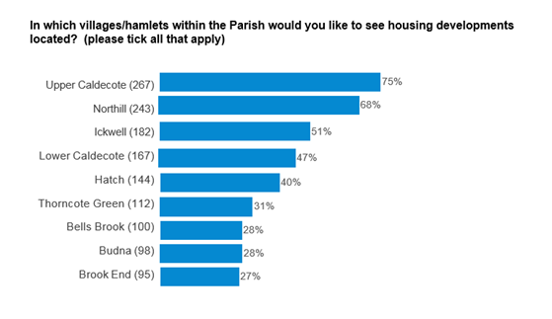

Figure 4 indicates a desire to spread development proportionally across the parish by order of size of settlement and supports the even spread of development across the parish mentioned in figure 5. The potential contradiction between these desires and figure 3’s stance of building within or adjacent to the settlement boundary is likely to be a lack of knowledge among parishioners about the implications of settlement envelopes on development.

No land has been made available to the Neighbourhood Plan Steering Group within the parish settlement envelopes. Proportional spread of new development across the parish settlements is possible within small and large villages (CBC 2009, CBC 2014) but not directly allowed for in the hamlets unless it can be achieved under a neighbourhood planning policy. Hamlets may not be best placed to support rural exception sites as access issues may exist to community facilities and transport which in turn reduces sustainability. However hamlets do need to retain their mix and vitality which can reduce as parishioners get older.

NPPF (2012) agrees that housing should be located where it will enhance or maintain the vitality of rural communities while promoting sustainable development in rural areas. New isolated homes in the countryside should be avoided unless there are special circumstances, one of which includes the exceptional quality or innovative nature of the design of the dwelling. Such a design should be truly outstanding or innovative, helping to raise standards of design more generally in rural areas; reflect the highest standards in architecture; significantly enhance its immediate setting; and be sensitive to the defining characteristics of the local area.

CBC 2014 Policy 5 states Neighbourhood Plans may allocate and bring forward land for development that is generally in keeping with the scale of the existing settlement, beyond the Settlement Envelope, Green Belt Infill Boundary or Green Belt boundary where there is no suitable alternative within the existing settlement.

CBC ( 2014) Policy 38 states

Beyond settlement boundaries only development appropriate to the countryside and specifically provided for in policy will be permitted.

The word policy in this context is unclear but may allow for a neighbourhood plan policy until 2031 to provide for a very small number of truly affordable infill market houses (preferably 2 bed) proportionate to the size of each hamlet.

**The Neighbourhood Plan should include within a sustainable housing growth policy**

* **Minimal market housing infill proportionate to the overall property numbers of the hamlets collectively and within the expected overall numbers stated.**
* **The opportunity for development combining truly affordable housing with exceptional design that fits well within hamlets and could be used as the blueprint for future development**

Types of Development

**Figure 5**

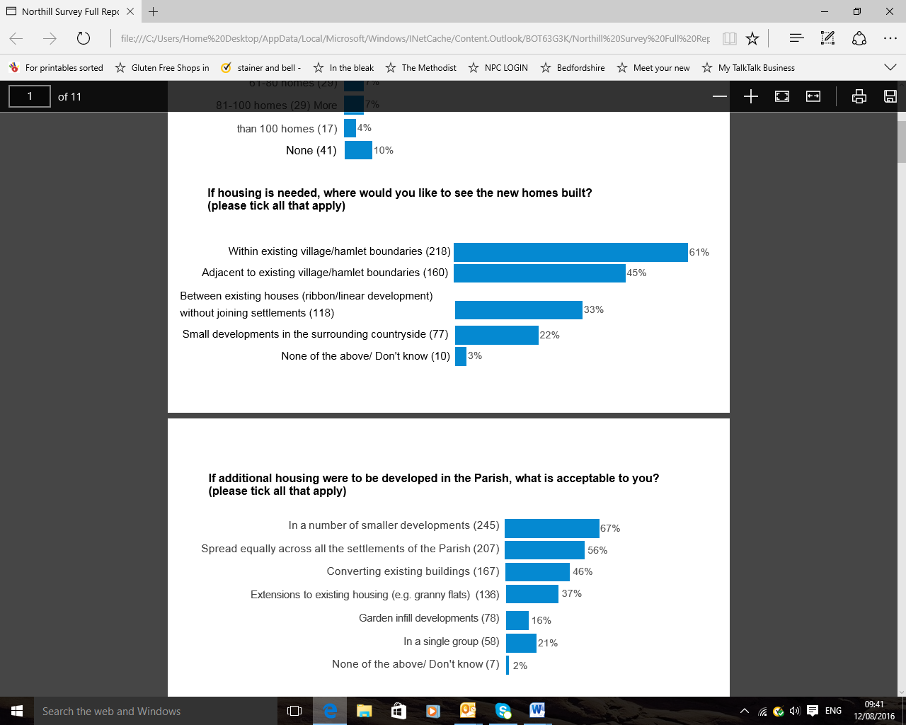

Figure 4 indicates that parishioners would prefer a number of small developments (245/67%) rather than one larger one (58/21%) and for those developments to be spread equally across the settlements of the parish. There is little support for garden infill developments (78/16%) but more support for extensions to existing housing (136/37%) to provide additional accommodation (eg. granny flats) and converting existing buildings (167/46%).

The question regarding garden infill was potentially misleading to parishioners who may have considered this to mean within existing gardens or to the back of existing gardens. It was supposed to gauge sponse from the parish on original workshop participants desire not to have building to the rear of existing property. CBC were asked for a definition of backfill or backland development but none was received so it was difficult to phrase a suitable question wIthin the space restrictions of the questionnaire format. However response to the site preference consultation consolidates the initial negative response from parishioners to building to the rear of existing properties and further comments ccan be seen below.

Development to the rear of existing properties

CBC Design Guide for Housing Residential Development (5.13) states that redevelopment should not take place at the expense or loss of the positive aspects of the character of the street scene, the area as a whole, or the unacceptable loss of amenity of the original house on the plot, or its neighbours. Development proposals should take cognisance of existing front boundary treatments and not result in the significant loss of characteristic boundary walls, hedges, gateposts etc, or the creation of new road junctions which result in the unacceptable loss of those features above or which are unacceptable within the terms of ‘Manual for Streets’. Where a rear garden adjoins countryside, the existing character of the interface between the plot and the countryside should influence the amount of proposed development. The scale/plot coverage, height, roofline, materials, fenestration and details should be noted and the proposed development should complement them. New development should avoid dominating the adjacent buildings and respect privacy of adjacent building

The largely linear development lines and mixture of settlement size in Northill Parish mean that local people have and value a close connection to the surrounding countryside at the rear of existing properties outside the settlement boundary. Typical comments during consultation included “use infill to the side of properties rather than behind existing gardens or on agricultural land – less impact on environment and residents,” “build along roadsides ie frontage development”, “do not eat into land behind houses”. Several parishioners commented on the value placed on being able to see wild animals and birds in the hedgerows and the countryside providing a peaceful buffer both between and within settlements. This closeness to the countryside was the reason many had left towns and cities to live in the Parish and featured in what parishioners liked best about the Parish.

**CBC Design Guide for Housing Residential Development (CBC, 2014b) is not sufficiently specific. If, as parishioners have indicated, they do not want development to the rear of existing gardens, a policy is required as only back garden development is covered within CBC (2009) and CBC (2014)**

Small Developments

CBC (2009) states that the Sites Allocation DPD allows the local authority to set lower minimum thresholds than the national indicative minimum site size of 15 dwellings. In the Northill Parish area (old Mid Bedfordshire) around half of all new homes came forward on sites below the national indicative minimum threshold. A lower threshold was therefore justified and required to help meet the established level of affordable housing need locally. A threshold of four dwellings was considered to be appropriate in order to meet the affordable housing **requirement**. A Viability Study had assessed the impact of such a threshold and reported that for the sites investigated, there were no viability reasons that should prevent the Council adopting a new threshold at this lower level

Converting existing buildings

CBC (2014): Policy 52: supports the re-use or replacement of existing buildings in the countryside provided the proposal complies with the following criteria and other relevant policies:

* The building contributes to the rural setting in terms of its scale and appearance, and has a permanent and substantial construction capable of conversion.
* The proposals including, where appropriate, conversion to residential use, helps support the sustainability of existing rural communities and delivers positive benefits in terms of the immediate landscape setting.
* The re-use or replacement is sympathetic and in keeping with the character and appearance of the rural surroundings and in the case of re-use the appearance of the original buildings.
* No harm will be caused to features of architectural or historic importance; and would not be detrimental to protected species.

Supporting small developments in addition to converting existing buldings and extending existing homes conforms to both CBC (2009) and CBC (2014).

**A sustainable housing growth policy should include definition of small development, conversion, extension and replacement of buildings in the countryside. Use should be made of CBC 2014 above as criteria for re-use/replacement of existing buildings because CBC 2014 has no legal status.**

**There should be a separate policy for development to the rear of existing property**

Size of development

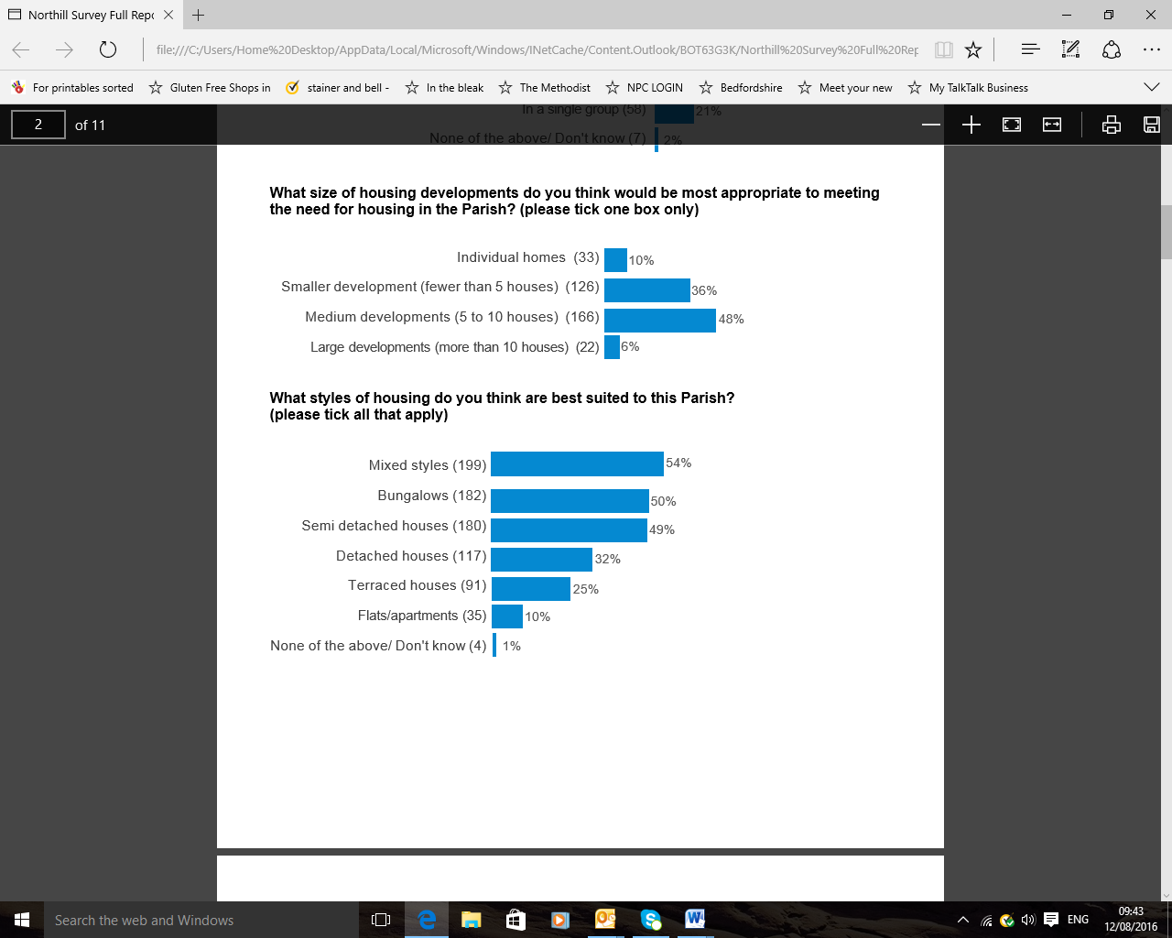**Figure 6**

Figure 6 shows that 347 /15.2%) parishioners answered this question which is considered an acceptable return. A clear preference is shown for developments of 10 or less homes (292/84%).

The desire for 10 dwellings or less in any development conflicts with CBC general stance in their call for sites of requiring 10 or more homes for a site to be submitted. According to CBC, “*the knock on effect of rejecting sites above 10 would be a missed opportunity to use the legal status of the Neighbourhood Plan to give feedback to CBC on any larger sites*”. An alternative approach suggested by CBC would be to use scale rather than numbers (ie proportionality to the settlement in question).

* Less than 5% of existing property numbers = acceptable.
* 5-10% = possible.
* >10% not acceptable.

In this way development could be proportionate to the size of the parish and each settlement without compromising the Parish Council’s abiity to feedback on larger sites. In addition, CBC emerging LDF states (para 5,24) “Where a Neighbourhood Plan has identified significant new housing sites, the Allocations Local Plan will not then identify further sites.”

**A sustainable housing growth policy should comsider incorporating proportionality in regard to size of development**

Housing Style

**Figure 7**



Figure 7 suggests that a mixture of housing styles are required with bungalows and semi detached houses being the most suitable. The need for bungalows reflects the BRCC Housing Needs Survey 2015’s findings for market housing needs which also showed that in order of priority, 2 bed properties (25) were required, followed by 3+ bed (18) and 3 bed (12) properties. BRCC, 2015 had included alongside the term bungalows, retirement housing. The strength of opinion on bungalows may, therefore, reflect the needs of a growing elderly population within the parish.

Having a mixture of styles within developments is in accorance with both the CBC (2009) and CBC (2014).. However bungalows are expensive to build and generally occupy more land footprint than houses. A compromise may be to consider ensuringthat every future dwelling built in the parish conforms to Lifetime Homes Criteria making them adaptable for all ages and physical conditions as recommended in BRCC, 2015.

**A sustainable housing growth policy should include mandatory design to Lifetime Homes Criteria on all properties**

Housing Type

**Figure 8**

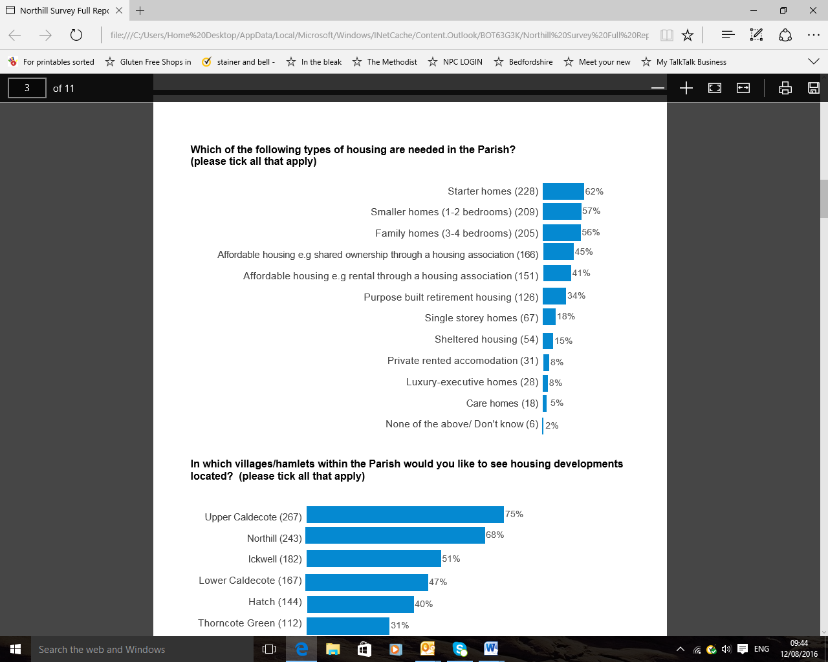

Figure 8 indicates a higher percentage of parishioners wanted starter homes, (1-2 bed homes and 3-4 bed homes) than affordable housing (both rented and shared ownership) although the latter was still required. This may indicate a desire to be able to buy rather than rent property if the chance was available. Equally the number of people wanting affordable homes may be small compared to the overall number completing the questionnaire. Appendix 1 gives more information on starter homes. The requirement to have land that has been in commercial or industrial use is paramount. Northill Parish has little such land available.

There appears to be little demand for executive homes, care homes, private rented accommodation, single storey homes or sheltered housing but some demand for purpose built retirement housing. The latter may reflect a larger than average elderly population

Delivering a mixture of housing types conforms to both CBC (2009) and CBC (2014).

**The Neighbourhood Plan should have a housing mix policy which includes style, type tenure and takes account of conservation issues**

Housing quality

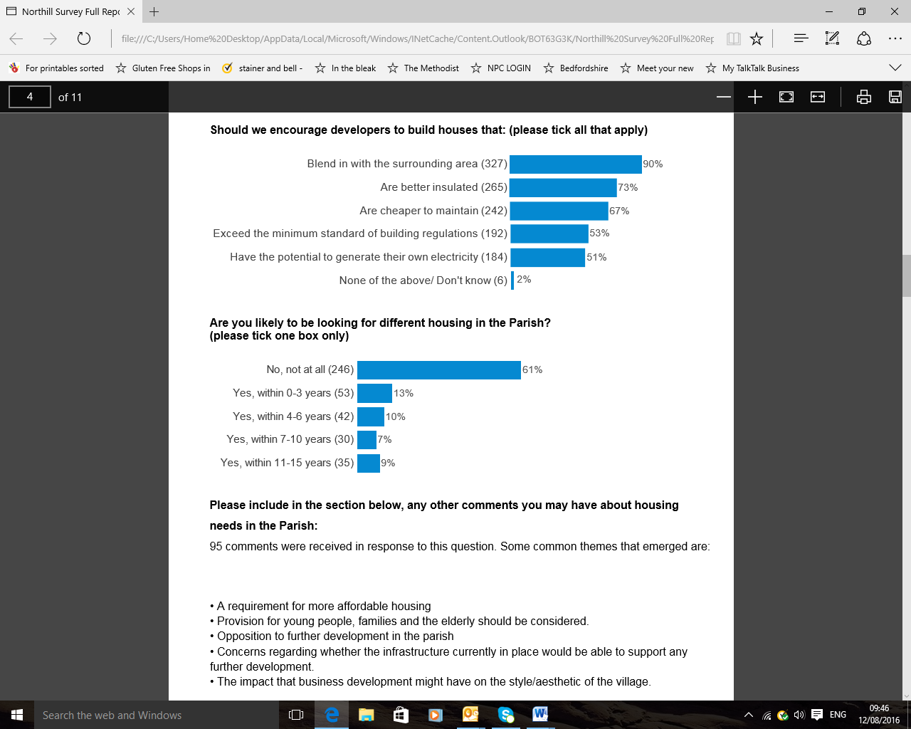**Figure 9**

***Conformity with local plan***

**All of the goals shown above conform to the 2009 and 2014 emerging CBC plans. Blendability as a design principle is no exception but requires an explanation of what the word includes/excludes**

Question 9 indicates that parishioners feel the most important design component in new development is being able to blend in with the surrounding area. Good insulation and cheap maintenance are also required. Just over 50% of those answering the question felt that development should exceed the minimum standard of building regulations and have the potential to generate electricity.

**Figure 10**

Figure 10 shows 39% (157) of those answering questions expect to be looking for different accommodation in the Parish within the lifetime of the neighbourhood plan. If they find what they want there could be a significant effect on freeing up market housing for sale

**Conservation**

There are two conservation areas in Northill Parish, one in Northill (MBDC 19 May 2004) and one on Ickwell Green (MBDC date to be added). Guidance from those two documents should be used to formulate future housing policy.

**7. Site assessments**

Conflict of interest was declared by one co-chair of the neighbourhood plan steering group who took no part in decisions made around the site assessment process, consultation or outcome. Conflict of interest was also declared by two steering group members about certain potential sites. They took no part in discussion about these sites at outcome or consultation. Site Assessment process and outcome is contained within a separate Site Assessment report.

**8. Conclusions**

**Various policy and non policy considerations have been highlighted throughout this report and are gathered below under suitable headings**

**9. Policy Considerations:**

General Policies Recommended to the Steering Group

1. The Neighbourhood Plan should have a policy for sustainable housing growth which ensures:
   1. Around 40 dwellings until 2031.
   2. Provision of up to 10 market housing units favouring 2 bed properties x 5, 3 beds+ x 3. 3 beds properties x 2 before 2020
   3. development outside the settlement area which incorporates the needs of the hamlets and is not contrary to CBC requirements, possibly using infill in hamlets
   4. potential growth adjacent to the settlement envelope
   5. Definition of high quality design, infill, small development, conversion of existing buildings, extension
   6. mandatory design to the 16 design criteria for Lifetime Homes Standard and BREEAM standards on all properties.
   7. The use of open space for community planting as part of a development
2. The Neighbourhood Plan should have a policy on quality of build.
3. The Neighbourhood Plan should have a policy for development to the rear of existing property
4. The Neighbourhood Plan should have a housing mix policy which includes style, type and tenure and conservation
5. The Neighbourhood Plan should ensure that all Water Management policies are amandatory with any housing development
6. The Neighbourhood Plan should ensure that policies within other areas of the Plan that affect housing development are referenced to the housing policy section

Affordable Housing Policies required

1. The Neighbourhood Plan should have a policy on rural exception. Rural exception sites should allow a proportion of market housing to make the site viable and sustainable but still retain the affordable housing for local connected people first.

Miscellaneous

1. The Neighbourhood Plan should use the remainder of site assessment questions to shortlist preferred land for development
2. The neighbourhood plan should have a design statement which incorporates the requirements for delivery of truly affordable modular / eco housing which meets the standard required for exceptional quality or innovative nature of the dwelling design and meets the following criteria
   * be truly outstanding or innovative, helping to raise standards of design more generally in rural areas;
   * reflect the highest standards in architecture and building construction standards;
   * significantly enhance its immediate setting; and
   * be sensitive to the defining characteristics of the local area
   * include wi-fi and electricity generation.

**10. Non policy considerations**

1. Ensure housing needs assessments in 2020 and 2025 which include differentiation between the parish and the settlements by name, further research into shared ownership as a viable option for local people, attitude towards Lifetime Homes rather than bungalows and the most sustainable part of the parish in which to site affordable housing.
2. Further research is required into the options of self build / community self build / Community Land Trust and Modular Housing as a means of access to truly affordable market housing locally. The interest of landowners in such a venture should be sought.

**References.**

Bedfordshire Rural Communities Charity (2015). Housing Needs Survey Report Northill. Bedfordshire Rural Communities Charity.

Central Bedfordshire (2009). Local Development Framework Former Mid Bedfordshire Area. Core Strategy and Development Management Policies. Central Bedfordshire

Central Bedfordshire (2014). Development Strategy for Central Bedfordshire.Revised Pre-submission Version. Central Bedfordshire

Central Bedfordshire Council (2014a) Affordable Housing and Neighbourhood Plans Briefing Note.

Central Bedfordshire Council (2014b). Design Guide. [www.centralbedfordshire.gov.uk/planning/**design**/info.aspx. Accessed 1.8.16](http://www.centralbedfordshire.gov.uk/planning/design/info.aspx.%20Accessed%201.8.16).

Central Bedfordshire Historic Design Guide (2014)

Communities and Local Government (2012). National Planning Policy Framework. Department for Communities and Local Government

Ickwell Conservation Area – MBDC date TBC

Northill Conservation Area - MBDC 2004

Northill Parish Council (2008), Northill Parish Community Plan Northill Parish Council.

Northill Parish Council (2015) Your Neighbourhood Plan Questionnaire.

**Appendix 1: Starter Homes**

The Central Bedfordshire Local Planning and Housing Team e mailed the following statement on 18 1 17. “There is currently very little guidance on Starter Homes. We expect the White Paper to announce in more detail the expectations surrounding Starter Homes. Within the housing policies for the emerging Local Plan, we have drafted a Start Homes Policy as we expect to have an obligation as a Council to consider the delivery of Starter Homes from development sites. The Housing and Planning Act 2016 sets out the Governments agenda to support homeownership, particularly through the delivery of Starter Homes. The exact proportion of starter homes to be delivered is still under debate as the proposed 20% requirement cited in the consultation on starter homes was not actually enshrined within the Act. I would expect we will be in a better position in terms of understanding the position on Starter Homes with the release of the White Paper – which is expected to be fairly imminent”.

Starter Homes can be offered to young first time buyers at below their open market value The exception site policy enables applications for development for Starter Homes on under-used or unviable industrial and commercial land that has not been currently identified for housing. Suitable sites are likely to be under-used or no longer viable for commercial or industrial purposes. Although Northill Parish may have some unused agricultural buildings, most landowners have arranged for small businesses to let the premises. It is not known if agricultural premises would be considered suitable within this scheme (ref).

The following information was gained from the Internet but may not be current as there has been a change of government and prime minster within the intervening time.

The [Written Ministerial Statement](http://www.publications.parliament.uk/pa/cm201415/cmhansrd/cm150302/wmstext/150302m0001.htm#1503022000006) ([www.parliament.co.uk](http://www.parliament.co.uk) written statement 2.3.15 accessed 1.9.16) sets out how the Starter Homes exception sites policy helps to meet the housing needs of young first time buyers, many of whom increasingly cannot afford to buy their own home, by allowing Starter Homes to be offered to them at below their open market value. The exception site policy enables applications for development for Starter Homes on under-used or unviable industrial and commercial land that has not been currently identified for housing.  It also encourages local planning authorities not to seek section 106 affordable housing and tariff-style contributions that would otherwise apply. Local planning authorities should work in a positive and proactive way with landowners and developers to secure a supply of land suitable for Starter Homes exception sites to deliver housing for young first time buyers in their area.

Starter Homes exception sites are expected to be on land that has been in commercial or industrial use, and which has not currently been identified for residential development. Suitable sites are likely to be under-used or no longer viable for commercial or industrial purposes, but with remediation and infrastructure costs that are not too great so as to render Starter Homes financially unviable.

The types and sizes of site suitable for Starter Homes are likely to vary across the country, and will reflect the pattern of existing and former industrial and commercial use as well as local market conditions. Land in both public and private ownership can be considered.

Where applications for Starter Homes come forward on such exception sites, they should be approved unless the local planning authority can demonstrate that there are overriding conflicts with the [National Planning Policy Framework](http://planningguidance.communities.gov.uk/blog/policy/) that cannot be mitigated.

Local planning authorities can take into account a number of factors when assessing whether an industrial or commercial site is underused or unviable. Indicators may include whether:

* the land value for the site is significantly below that of other sites with a similar permitted use in the area;
* there is a high percentage of vacant units, and whether these have been vacant for some time;
* land allocated for employment use has not been marketed actively for some period of time or, if actively marketed, has failed to attract any interest over a reasonable period of time; and
* there has been a lack of recent development activity to improve the commercial or industrial site.

Employment land which is being used productively or which is allocated and viable for employment purposes is not to be regarded as underused or unviable.

Local planning authorities can use their discretion to include a small proportion of market homes on Starter Homes exception sites where it is necessary for the financial [viability](http://planningguidance.communities.gov.uk/blog/guidance/viability-guidance/) of the site. The market homes on the site will attract section 106 or [Community Infrastructure Levy](http://planningguidance.communities.gov.uk/blog/guidance/community-infrastructure-levy/) contributions in the usual way.

**Appendix 2:**

**Self build**

The [Self-Build and Custom Housebuilding Act 2015 (link opens in new window)](http://www.legislation.gov.uk/ukpga/2015/17/contents) places a duty on local councils in England to keep and have regard to a register of people who are interested in self-build or custom-build projects in their area. This register will help inform the council of the level of demand for self-build and custom-build plots in the Central Bedfordshire area and enable the council to develop a strategy for delivering serviced plots for self-build and custom-build projects.

Self-build and custom-build housing is housing built by individuals or groups for their own use, either by building the home on their own or by working with builders.

Self-build projects are defined as those where someone directly organises the design and construction of their own home. This covers a wide range of projects, including a traditional DIY self-build home to projects where the self builder employs someone to build their home for them. Community-led projects can also be defined as self-build.

Custom-build homes are where you work with a developer as an individual or a group to help deliver your own home. The developer may help to find a plot, manage the construction and arrange the finance for your new home. This is more of a hands-off approach, but your home will be tailored to match your individual requirements.

Homes built in this way offer an alternative to standard market housing that may not meet your household’s needs. Self and custom-build homes can be built to your own specification, subject to both [planning guidance and regulations, and building regulations compliance (link opens in new window)](http://www.centralbedfordshire.gov.uk/planning/policy/landing.aspx). They offer opportunity for innovative design to make greener and more affordable than standard housing.

The eligibility criteria for an entry onto the register are set out in the [Self-Build and Custom Housebuilding Act 2015 (link opens in new window)](http://www.legislation.gov.uk/ukpga/2015/17/contents). The Act specifies, that to be eligible, an individual must be:

* aged over 18
* a British citizen, or a national of an EEA State other than the United Kingdom, or a national of Switzerland
* seeking to acquire a serviced plot of land in the CBC area to build a house to occupy as that individual’s sole or main residence

An association is eligible for entry if each member meets all of the eligibility criteria set for an individual.

A full self build project is a major undertaking, and only a relatively small proportion of people actually take this on. It tends to suit people who have built before, or who have some link to the construction industry, though there are plenty of examples of people doing it with no previous experience

| Self build do it yourself | |
| --- | --- |
| **Benefits** | **Challenges** |
| * It usually works out cheaper – saving typically 20-40%. * You get what you want. * Your know the building inside-out and are sure it has been well built. | * It is riskier – and unless you know what you are doing there is a chance you could make some costly mistakes. * It is very hard work – you'll be on site working long hours every day for many months. * Building a home is complex and complicated, and there are lots of formal approvals and certification issues to wrestle with. |
| Self build - Contractor built one-off home | |
| **Benefits** | **Challenges** |
| * You get exactly what you want (provided the planners are happy to approve it). * If the design is straight forward and the project is well managed it can be reasonably cost effective. | * Sometimes costs spiral – especially if you make changes to the design as the construction work progresses. * Professional fees can be a significant portion of the total cost, so you may want to negotiate fixed fees. |

| Self build - Kit home | |
| --- | --- |
| **Benefits** | **Challenges** |
| * It is simple and relatively risk free. * It is usually one of the fastest ways of getting a home built. * It is fairly simple to get a home built this way. * Some kit homes are quite modestly priced. | * There is sometimes limited design flexibility as the kit can usually only be modified a little. * Some of the top-of-the-range kits can be quite expensive. |

| Self build - Independent community collaboration | |
| --- | --- |
| **Benefits** | **Challenges** |
| * It is one of the lowest cost routes to self build - typically saving 40% on plot costs and an extra 10% on building costs. * You get to know your neighbours as you do it. * In most cases you have flexibility over the design of your home and how you build it. * You can influence the wider area too - so you might also include communal play areas for your children, allotments or other features as part of the overall scheme. | * It can take time to get a group together, and to get a clear consensus on how to use a larger site; sometimes there can be disagreements that are tricky to resolve. * It can be difficult to raise the finance to buy a larger site. Some people may let you down - for example they may not finish their home as fast as everyone else, or 'pull their weight' on communal tasks. |

| Self build - Supported community self build group | |
| --- | --- |
| **Benefits** | **Challenges** |
| * It enables people on low incomes to build a home – either for rent, part ownership or full ownership. By working as part of a group costs are minimised. * You get to know your neighbours as you do it. * You can influence the wider area too – so you might also include. communal play areas for your children, allotments or other features as part of the overall scheme. | * It can take time to get a group together, and to get a clear consensus on how to use a larger site; sometimes there can be disagreements that are tricky to resolve. * It can be difficult to raise the finance to buy a site or to get funding or a donated site via a social landlord. Sometimes projects also need grants to be secured to make them fully viable and this can be challenging. * Some people may let you down – for example they may not ‘pull their weight’. |

| Custom build - Developer built one-off home | |
| --- | --- |
| **Benefits** | **Challenges** |
| * It’s generally quick, simple and easy to do as they take care of everything. * You can sometimes arrange with the developer for you to finish off the work yourself - this can result in savings of 10-20%. | * There is a growing - but limited - number of developers offering this option around the UK. * It tends to be a more expensive solution as the developer will want to recover all his costs and make a fair profit. |

| Custom build - Developer led group project | |
| --- | --- |
| **Benefits** | **Challenges** |
| * It is simple and relatively risk free. * You can have a say in the design – perhaps choosing a design from a selection in a book of plans. * It is usually cheaper than buying a home off the shelf or from a conventional housebuilder. * You can sometimes arrange with the developer for you to finish the work off – so the developer constructs a watertight shell and you then tackle the rest. * This can result in savings of 10-20 per cent. | * Currently there are very few developers offering this option – so there are only a handful of projects or opportunities currently underway in the UK. * It tends to be more expensive as the developer will want to recover all his costs and make a fair profit. |

**Useful sites**

<http://www.selfbuildportal.org.uk/self-build-one-off-home> offers a variety of information on self build including what you have to do and next steps. The website also shows what to do if you need a plot, case studies, events and suppliers directory. It is produced by the [National Custom & Self Build Association](http://www.nacsba.org.uk) (NaCSBA) and is endorsed by the Government. Other computer sites to consider

[www.selfbuildportal.org.uk](http://www.selfbuildportal.org.uk)

[www.communitykindtrusts.org.uk](http://www.communitykindtrusts.org.uk)

[www.communityselfbuildagency.org.uk](http://www.communityselfbuildagency.org.uk)

**Appendix 3**

**Affordable Modular Housing**

**The modular housing concept**

Modular housing consists of prefabricated sections which are manufactured off-site and assembled and constructed on-site. Prefabricated sections are lifted and placed on pre-laid foundations and joined together to make a single building. Modules can be placed side-by-side, end-to-end, or stacked, allowing a wide variety of configurations and styles in the building layout.

Modular housing is not just a new name for “prefabs”. Modular dwellings must be designed and built to meet the same building standards as houses built on-site from scratch and meet the same inspection requirements.

Modern modular residences are built to high specifications and sustainable standards and designed to be low cost, low maintenance and environmentally friendly.

**The Government perspective**

The government commissioned a Report on Offsite Housing in February 2013 whose findings it accepted. The findings of the report make a strong case for the affordability and sustainability of modular housing.

*Offsite construction offers a route to delivering homes that can be built to higher sustainability standards, with potential advantages in terms of build quality, speed of delivery, construction health and safety, energy-in-use, whole-life carbon footprint, and reduced transport pollution (congestion and emissions).*

*Of these advantages, the ones which are most easily quantified are the financial benefits to the housebuilder associated with increased speed of construction and reduced working capital requirements, the ease of achieving higher quality construction (driven by the need to increase energy performance), and the savings to the householder which arise from reduced energy-in-use.*

The same report asked a sample of residents of modular housing whether they perceived any advantages of living in a modular dwelling. The householders identified the following:

*1 Reduced Construction Costs*

*2 Reduced Construction Time*

*3 Increased Quality of Finish*

*4 Increased Flexibility of Construction Programme*

*5 Lower Energy in Use Costs*

*6 Lower Life-time Maintenance Costs*

*7 Increased Lifetime Flexibility*

Central government announced in November 2017 that it will make a huge investment in the production of modular homes as a prime solution to the need for bulk affordable housing in urban areas.

In addition The Secretary of State has just completed (January 2017) a European tour of modular social housing projects and has stated that recommendations arising from this visit will be included in a Paper on Meeting UK Housing Needs to be released shortly.

**What sort of housing?**

There are a considerable number of UK based manufacturers (as well as German, Scandinavian and Chinese companies setting up UK bases). There are many different styles and types of provision using different materials.

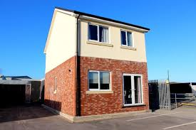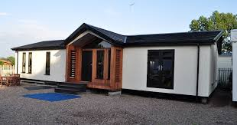  
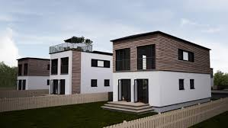 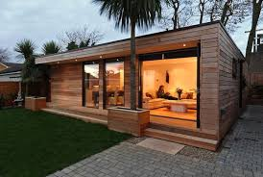

What is common to most of them is the claim to be able to design flexibly to meet local needs, to build to high accredited standards for sustainable and lifetime housing and to ensure that properties are acceptable to insurers, mortgage companies and are warranted. Some builders offer the standard NHBC 10 year warranty; others offer a more comprehensive and longer ranging package through industry umbrella organisations.

**Relevance to local needs**

1. Initial building costs can be substantially reduced compared to the same size house built by more traditional methods.
2. Outgoings on heating and power can be reduced substantially by the high grade insulation that is now the industry standard, air-tightness in the construction and electricity generating capability. These features are now common in all good quality modular builds.
3. Many modular house builders work in association with Housing Associations to ensure that local needs are addressed in terms of types of property and affordability
4. Mortgages and insurance are now readily obtainable and some modular build companies include these in their project delivery packages.
5. Additional modules can be inserted in future to change the number of bedrooms for example.
6. Choice in design and build can be offered.
7. Shared facilities on small developments can lead to greater efficiencies and lower costs.

**An Example** studies

**Case study 13: Goodwin Development Trust**

**– Villa Place, Hull, Premier Modular Ltd**

Premier Modular Ltd worked with The Goodwin Development Trust to design a housing block that would ensure a high quality of life for their residents. The ambition was to create the first Level 5 in the Code for Sustainable Homes (CFSH) for social housing in Hull (CLG, 2010).

The development consists of five terrace houses on the Thornton Estate located on the outskirts of Hull City Centre. The houses are three-bedroomed, five-person units, which incorporate innovative architectural design, energy saving materials and use renewable energy resources all designed to attain Level 5.

Key design features include photovoltaic panels, a communal rainwater harvesting tank, greywater recycling, triple glazed windows and doors, restricted water use per day, incorporating dual flush toilets and mixer taps/showers, low energy light fittings throughout and integral recycling bins in each kitchen.

To complement the sustainable design each property has a secure bicycle store and storage space for refuse, recycling and compost bins. The development was finished with a community planting area to promote growing food and biodiversity while encouraging social well-being.

Project value: £390,000

Site programme: 12 weeks

